**BCVD1007 – Full Stack Development IIl – Exam**

* Final Exam

**Developer Note:**

* Use the web documentation for Node.js
* Try to build it stages for marks, please submit one version of finished application

<https://youtu.be/FpUnsv3uqqw> (Demo Link)

**Task:**

Build a simple ping pong simulation using **Node.js** with event emitters and asynchronous methods.

Stage 1: Event Emitter (4 Marks)

* Using event emitters do the following
  + create a function named **playGame** that will take the number of rounds param num
  + create an event listener for the ‘**ping**’ event, this will trigger the ‘**pong**’ event
  + create an event listener for the ‘**pong**’ event, this will trigger the ‘**ping**’ event
  + invoke the **playGame** function to trigger the first ‘ping’ event
  + keep track of the number of rounds and stop triggering to **exit** the program
* **Invoke** the **playGame** function in your script, the following way  
  
* The expected output is as follows

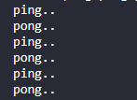

Stage 2: Asynchronous Behavior (4 Marks)

* Add some asynchronous behavior to add a 1-2 second delay before each event is triggered.
* Add an output for the **Round** number to the console.
* Add a process exit with a code of zero when the number of rounds have completed
  + log to console **game is over**..
* The expected output

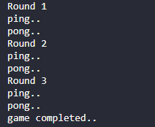

**Submission**

1. The exam question will uploaded and submitted to Black Board

|  |  |
| --- | --- |
| **Specification** | **Points** |
| Stage 1: Event Emitter | 4 Marks |
| Stage 2: Asynchronous Behavior | 4 Marks |
| **Total** | **8 Marks** |